Project Development Phase
ServiceNow Reports & Dashboard Performance Test

Date | 30 September 2026
Team ID | SN-TRANSFORM-01
Project Name | Import Data using Transform Maps (Spreadsheet)
Maximum Marks | 4 Marks

ServiceNow Reports & Dashboard Performance Test:
This report adapts the dashboard template to validate ServiceNow reports and Employee Analytics Dashboard behavior.
S.No. | Parameter | Screenshot / Values
1 | Data Rendered | Employee Test records are visible after transform; expected five fields render in the report source. | Pass
2 | Data Preprocessing | Source rows are staged, mapped and validated before report use. | Pass
3 | Utilization of Filters | Department, Location and Employee ID filters return the expected subset. | Pass
4 | Calculated Metrics Used | Counts of employees, inserted rows, updated rows, ignored rows and errors. | Pass
5 | Dashboard Design | Employee Analytics Dashboard shows current import outcomes and employee summaries. | Pass
6 | Report Design | Department pie, location bar and employee-list views are readable and traceable. | Pass

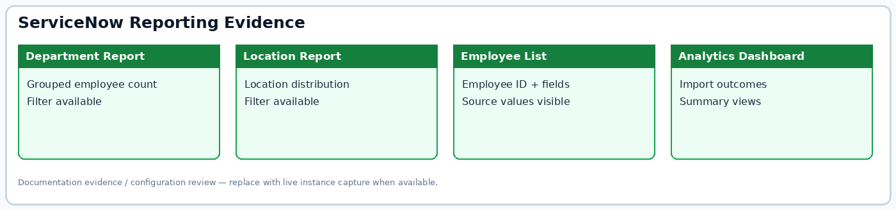
Figure: Project reporting evidence summary.

